## Recap

Interoperability means ability of a system to work with or use the parts or equipment of another system. In Internet of Things while some device sharing information with others to perform a mission in a group called interoperability on the IoT. By interoperability, IoT will enable global connectivity between physical objects (rather than connecting places or people), will be able to delivery any type of info from source to destination in real time. Idea of IoT is already taken place in market, Smartphones are being connected with household devices, screen are sharing with other displays, smart fridges are giving command to oven. These way those are being also interoperable, which has also some limitations e.g. one single vendor is tempting us to buy all kind of devices/machines from him as sometime it hard to make pair with other vendor's devices.

Currently large number of non-interoperable IoT platforms in market with small penetration, shortage of efficient application programming interfaces (APIs) even if API available lack of interoperability forcing to develop software separately but small market is not attracting developers therefore most often software from the hardware vendor that is available to end users. But the vision of IoT interoperability is to gain ability to devices from different vendors, interconnect all IoT devices and software at once, allow 3rd parties to develop software applications for IoT environments in contrast to applications coming only from the devices’ vendors. To reach to the vision we can consider two way either standardize everything or Some level of standardization and apply of some intelligence.

There have been a trend of adding different real world thing with existing web infrastructure to use all things as a recourse is called the Web of Things (WoT).

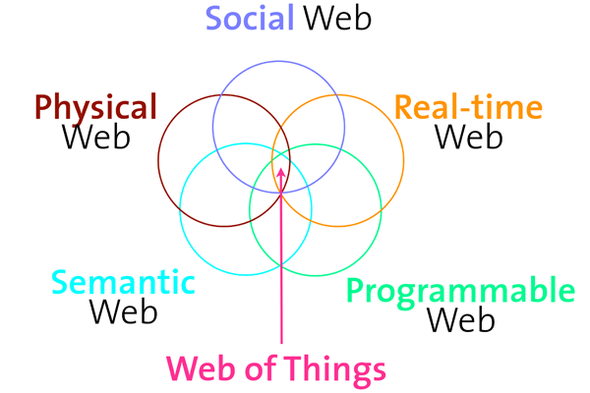

Appling the web architecture to IoT is opening scope of interoperability, for efficient interoperability we need make the devices intelligent to understand semantic interoperability, therefore devices would perform according conveyed meaning of data what they may get through communicate over Web protocols.

## Problem

Vision of IoT interoperability was stated nicely but I found problem how to reach to destination specially " install and interconnect all IoT devices and software at once". There was two real life scenario about Mary but we had not get chance to know correct solution.

# Perception

As a WISE student we have already started to work on everything to everything interface. It would be really a wonderful if we can implement concept of semantic web, IoT, WoT and internet agent. Same data can be used by many agent for many purpose and human as well ( human is also an agent), creation of artificial intelligence would be easier.

## Criticism

While things are depending on each other than being in up time with good condition become very necessary for the whole chain or the system need to be intelligent enough for self configuration therefore extra complexity will be there. Privacy and security would be a matter of question while everything is possible to access over internet. IoT trend also increasing production of different electronics product what would aggravate environmental pollution.

## Deepening

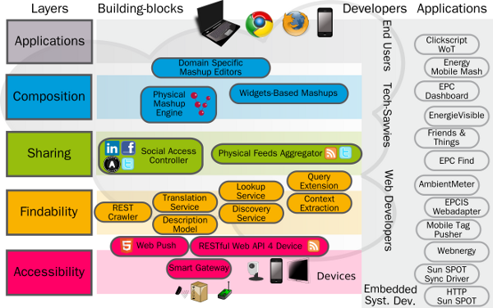Biggest challenges in IoT implementations are presence of Low-powered devices (which need to function for long time without getting any power) and the data exchanges over a lossy network. Due to this characteristics and challenges the use of of the existing internet protocols to be less than ideal and sub-optimal. We have already moved from the HTTP, TCP, IP stack to the IoT specific protocol (CoAP). Applying Web architecture to Internet of Things is a great facilitator of interoperability, if we look the architecture of web of things

The accessibility layer deals with the access of things to the Internet, extend services through API to create an interoperability environment. Findability layer provides a way to find and locate things on the Web specially based on semantic relation. Semantic standards describe IoT and services; HTML5 Microdata integration, RDF / RDFa, JSON-LD enable searching for things human readable and machine readable form.

# Reference

1. http://webofthings.org/2011/12/01/phd-web-of-things-app-archi Khandker, Syed Ibrahim

WISE